7 Man Football
Fee: $80 Payable to GAC
Send no money until teams are formed.
Register by:
The Greentown Football Association is excited to announce a new youth flag football program designed to teach players football basics, teamwork and sportsmanship in a non - contact format. For more details see sports page on our website.

Greentown Athletic Club: P.O. Box 159 Greentown, OH 44630

Website: www.greentownac.org

Email: greentownac@gmail.com

Phone: 330 - 494 - 3928

-----------------------------(Detach bottom and mail to address above)--------------------------------

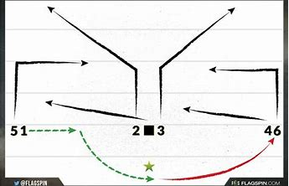
Please print clearly below:

Name: _____________________________

Address: ___________________________

City/Zip: ___________________________

Phone for texts: _____________________

Email: _____________________________

Grade as of August 2018: 2 3 4 5 6 7

Would you like to coach: Yes No

I do hereby waive, relinquish and hold harmless, the Greentown Athletic Club, Inc. representatives, agents and employees of the above, from any and all liability from any physical or mental injury which arises from, or is incurred directly or indirectly through my child’s participation in the 7 man Football League.

Signature: ____________________________________ Date:______/______/______

